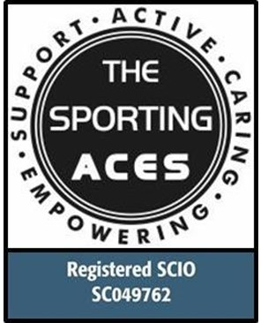
Participants Information Sheet / Consent Form
Participant Information
Name:

Home Address:

Postcode:

Date of Birth:

Email:

Contact Number:

School/College:
Volunteer/Work Placement

1st Emergency Contact (Relationship to Participant) _________________________

Name:

Home Address:

Postcode:

Mobile Number:

Email:

2nd Emergency Contact (Relationship to Participant) _________________________

Name:

Home Address:

Postcode:

Mobile Number:

Email:

Information on Additional support needs:
Any Medical information we need to know about (including any allergies):
Please continue on a separate sheet of paper if required:

Information for Parent / Carer / Participant

The Sporting Aces aims to provide a safe and enjoyable experience for every child or young person. To help us do this, please note the following important information.

- All questions on the consent form must be completed and signed by the Parent / Carer / Participant before taking part.
- Parent / Carer / Participant must ensure they notify us of any changes to the information given on the form.
- If the participant is unable to attend a session, please give as much notice as possible to the Head Coach.
- We cannot take responsibility for any damaged clothing and / or personal items during the activity.

I agree to _______________________ taking part in the stated activity and The Sporting Aces keeping a record of this form for health and safety reasons and any medical treatment that may be required in an emergency.

All participant information sheets must be signed by a responsible adult over the age of 18.

Relationship to Participant or Participant

Print Name:

Signature:

Date:

This form will be reviewed annually. Updated: 8th April 2022
Photography and Video Consent Form
Consent Information
To be completed by Parent / Carer / Participant

All participant consent forms must be signed by a responsible adult over the age of 18.

- I consent to The Sporting Aces photographing or videoing:

Name of participant: ……………………….………………………………………….

Relationship to participant
or participant: …………………………………………………………

Signed by: Print name: …………………………………………………………………

Signature: ………………………………………… Date: ……………………………

- The photos / videos may be displayed on The Sporting Aces social media pages (Facebook/Twitter/Instagram), the group Website, or the local paper. The photographs or videos may also be used for case studies for our funders. The Charity uses the photos/videos to promote good news stories. Important: No names will ever be attached to photos.

I understand that The Sporting Aces will cease to post photos of the named participant when they leave the Charity, or when I withdraw consent. I am aware that photos/videos currently on the social media pages will continue to show on the timeline.

Signing this consent is my agreement that I understand that the named participant will continue to be on The Sporting Aces timeline or other social media pages even after they have left the Charity, or I have withdrawn my consent.

As you may be aware, Facebook is a timeline and photographs, and comments are there for as long as the Facebook page is open. The same applies to Twitter, Instagram, and case studies sent to the funders.

To be completed by Parent / Carer / Participant

- I do not give my consent to The Sporting Aces photographing or videoing:

Name of participant: ……………………….…………………………………….…….

Relationship to participant: …………………………………………………………

Signed by: Print name: …………………………………..…………………….……..

Signature: ………………………………………….… Date: ……….…………………

This form will be reviewed annually Updated: 8th April 2022

